UNIVERSITY OF CUMBRIA
COURSEWORK REASSESSMENT REQUIREMENT
Module Code: 7107

Module Title: Planning Enquiry: Research Methods and Ethics

Tutor: Rebekah Ackroyd

Title of the item of work:

Wordage:
3500 words
Details and Criteria: ( Please attach additional sheets if necessary)
Please see attached level 7 criteria on the pages below and the learning outcomes below
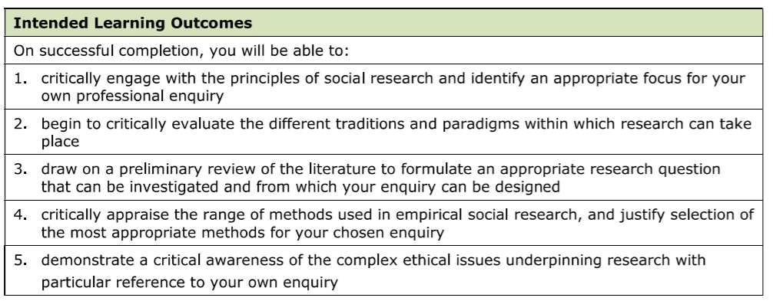

SUBMISSION DATE AS PER STUDENT PORTAL

To be submitted by 04:00 PM on 05/05/2023 via Turnitin on the Module
Blackboard site.

