UNIVERSITY OF CUMBRIA
COURSEWORK REASSESSMENT REQUIREMENT
Module Code: HSOB4004

Module Title: Introductory Microbiology and Immunology

Tutor: Dr. Wendy Davidson

Title of the item of work: Assignment 2

Learning Outcomes
- Demonstrate an understanding of the diversity and structure of micro-organisms.
- Demonstrate knowledge of the pathogenesis of some medically important micro-organisms.
- Demonstrate knowledge and understanding of the structure and function of components of the immune system and their mechanism of action.
- Demonstrate familiarity with a wide range of cells and be able to explain how their properties suit them for their biological function and how they may be investigated experimentally.

Details and Criteria
This assignment is weighted at 60% of the module.
You are required to complete all the 6 questions listed below in order to meet the learning outcomes in full. Each question has a dedicated word count (+/- 10%) and collectively they will target the learning outcomes (LO) illustrated above (LO1-4). It is important you refer back to the LOs throughout to ensure you are meeting the assignment requirements.
Harvard Referencing should be used throughout and the marking criteria is based on the rubric. Please note that your list of references may be presented collectively at the end of the coursework and will not contribute to the word count, however in-text citations will.
It is important you research around the subject matter and do not rely solely on material covered in class.
Introductory Microbiology and Immunology HSOB4004:
ANSWER ALL QUESTIONS

- The ELISA (Enzyme Linked Immuno-sorbent assay) test is a test routinely used to detect the presence of antibodies in the blood. Discuss the scientific principle behind the ELISA test commenting on its strengths and limitations.
(250 words).
- (a) Discuss what the following image represents commenting on both Antigen A and Antigen B.

(100 words)
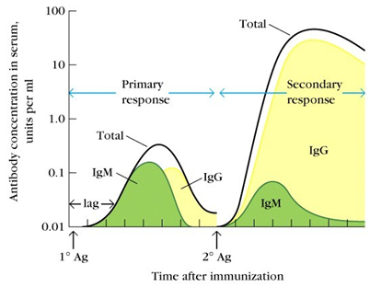
- (b) The Gram stain is the most widely used staining procedure in bacteriology. It is termed a differential stain as it differentiates between gram-positive and gram-negative bacteria. Describe both the stages of the Gram stain and the scientific principle behind the technique.

- words).

- The complement system refers to a series of >20 proteins, circulating in the blood and tissue fluids. In response to the recognition of microorganisms they become activated in an enzyme cascade. There are 2 main pathways utilised: Classical and Alternative. Discuss – commenting on key differences between the two.
(100 words)

- What does the image below represent? Discuss. (100 words)
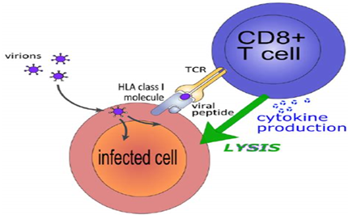

- Our immune system works to keep us healthy and protect us. Occasionally the system can become oversensitive resulting in reactions that can be harmful or in some instances deadly. Outline the 4 categories of Hypersensitivity commenting on the cells involved, stimuli and reaction stages. In addition, provide a clinical outcome for each.

- words)

- Bacteria and Viruses differ greatly in their morphology, behaviour and pathology. Discuss key morphological and behavioural differences between them.

(250 words)

SUBMISSION DATE AS PER STUDENT PORTAL

To be submitted by 4 PM on 26/05/2023 via Turnitin on the Module
Blackboard site.

