UNIVERSITY OF CUMBRIA
REASSESSMENT REQUIREMENT
Module Code: HS0Z5005

Module Title: British Wildlife

Tutor: Mary Farrell

Title of the item of work: PRACTICAL SKILLS EXAM

Wordage: 2 hours – 2000 word equivalent

Details and Criteria: ( Please attach additional sheets if necessary)

Rationale:

For anyone wishing to pursue a career with animals or conservation in the UK, a good understanding of British Wildlife is essential. The assessment will focus on identification skills and providing information on relevant aspects of each species' ecology, behaviour, threats and conservation.

Brief:
- For this assessment you will have a range of British wildlife species specimens (or photos) laid out in the lab in front of you.
- For each of specimen you will have some set questions. These may require you to:

  - Identify the specimen (to species, class or order level) and provide examples of characteristics that allowed you to identify it
  - Provide specific information about the specimen (e.g. ecology, behaviour, conservation, threats).

Learning Outcomes:
The following module learning outcomes are being assessed within this assessment:

- 1. Demonstrate in-depth knowledge of British wildlife populations
- 3. Demonstrate ability to identify a range of UK species

Format:
For this assessment you will have a range of British wildlife species specimens laid out in the lab. Each specimen will have its own station and associated question/s. You will move from station to station and answer the questions set for each specimen. The total time available will be 2 hours. Only short answers will be expected.

Example Questions:
1. Identify this species (3 marks) and provide two reasons (3 marks each) to justify your identification? (Total 10 marks)

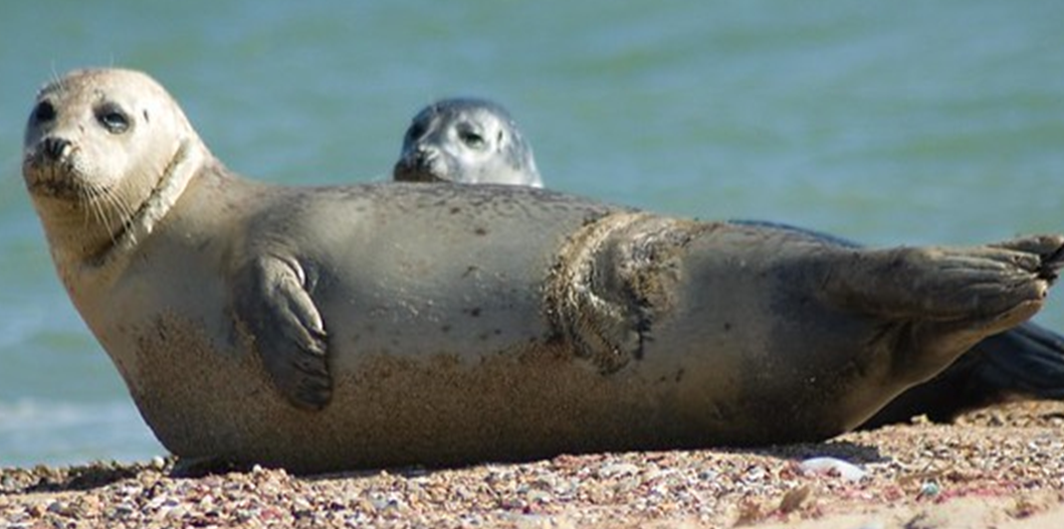

2. Identify the species (4 marks) and outline two current threats (3 marks each) facing this species in the UK (Total 10 marks)

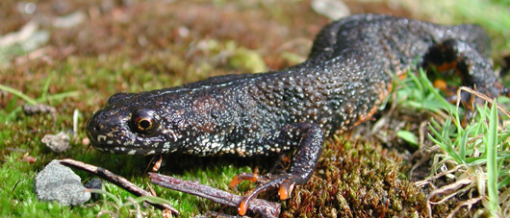

Marking Criteria and Distribution:
This assessment will be marked anonymously using your student number. Due to the nature of the assessment, there is no rubric. However, you may wish to familiarise yourself with the generic grade descriptors for L5 which give you a greater understanding of the benchmarks required for the second year of your degree – these can be found here within the academic regulations

SUBMISSION DATE AS PER STUDENT PORTAL

(please tick as appropriate but must be completed)
X
In person exam to be held from 3-5pm in BL008. To be submitted by 5:00 PM on 05/05/2023 in accordance with instructions given by the course team.

To be submitted through the Virtual Learning Environment (eg. Blackboard / Pebblepad etc.) in pdf format, or in person/by RECORDED DELIVERY to the Programme Administration at the Fusehill Campus of the University of Cumbria.

