

Department of Health, Psychology and Social Studies

PRACTICE PLACEMENT EDUCATION

HANDBOOK

MSc OCCUPATIONAL THERAPY (Pre-Registration)

2013 VALIDATED PROGRAMME

Updated September 2019

Contents

Page

Introduction 4

Curriculum Content 5

Practice Placement Information 6

placement Modules Aims and learning Outcomes 11

Assessment of practice placements 13

Practice Placement Responsibilities 20

Contacting the University 23

evaluation and assuring quality 24

References 25

Appendices 25

This information pack relates specifically to the Pre-registration MSc Occupational Therapy programme validated in 2013. The programme provides occupational therapy education for students on a full -time route at the Carlisle Campus. The new practice placement modules have been designed to ensure that practice education is an integral part of the academic programme, (details are outlined within this pack).

The information provided within this pack aims to provide practice placement educators’ working with occupational therapy students from the University of Cumbria (UoC) with essential information to enable you to collaborate effectively in providing quality practice experiences. Through partnership with our practice placement educators’ the university aims to provide students with a combination of practice based and classroom based education which will result in the emergence of competent occupational therapy practitioners.

Further information can be found on the University Learning in practice webpages:
www.cumbria.ac.uk/LIP

or try also

http://www.cumbria.ac.uk/Courses/SubjectAreas/HealthWellbeing/LearningInPractice/PlacementLearningUnit/Home.aspx

Please note that all 1st year students are now on the 2018 validated programme and you should refer to the 2018 Educator Handbook

Introduction

Practice Placement Educators Defined

Practice placement educators (PPEs) are occupational therapists who are registered with the Health & Care Professions Council, who work with service users and who supervise and assess students who are placed with them. Wherever possible, practice placement educators are expected to be APPLE accredited (RCOT) or be working towards their accreditation as a practice educator. It is not necessary that accreditation has been achieved through the University of Cumbria.

Defining Practice Placements

Within Occupational Therapy a block of learning undertaken in a work setting is termed a “Practice Placement” and is referred to in this manner throughout this literature.

The QAA provides the following definition of learning within a work environment:

Placement learning is regarded, for the purpose of this publication, as the learning achieved during an agreed and negotiated period of learning that takes place outside the institution at which the full or part time student is enrolled or engaged in learning. The learning outcomes are intended as integral parts of a programme of study. It is important that each student is supported by the institution throughout his/her placement experience, to ensure that specific learning related to the programme can be achieved (QAA, 2018).

Practice placements are an essential component of all Occupational Therapy programmes which lead to professional qualification. They enable students to develop the skills required to effectively interact with all services users, carers and professional colleagues within uni-agency and multi-agency teams as well as different agencies and organisations. Students are required to successfully complete 1000 hours of assessed supervised work based learning (World Federation of Occupational Therapists (WFOT) (2016) to be eligible for registration with the Health & Care Professions Council (HCPC) and for professional membership of the Royal College of Occupational Therapists (RCOT). This experience is essential in the development of competence to practice.

During the programme students will experience a variety of practice placements in a range of different settings. The Royal College of Occupational Therapists (2014) recommends that “students are exposed to a variety of clients across the life span and to a wide range of practice settings covering health & social care, as well as new and emerging areas of practice”. HCPC (2017) stipulate that students “gain access to a wide range of learning experiences in a variety of practice environments”. Practice placements are, therefore arranged within traditional settings (NHS and Social Services) and non-traditional settings (Private Health Care, Prison Services, charities) working with children, older adults, younger disabled people, physical disability, learning disability and people with mental health difficulties. There is also the opportunity to undertake practice placements in the Private & Voluntary Sector (PVI) during “role emerging placements”. In these placements it is not the norm for occupational therapists to be employed by the organisation and consequently there is no established occupational therapy role (RCOT 2006). Role emerging placements are recognised as “important learning experiences” and as “a means of expanding the boundaries of practice” (RCOT 2006). Due to the level of knowledge and skills required these placements are normally restricted to Level 6 (year 2) of the programme.
Note: Although this is a Masters level programme as it is pre-registration students are developing the skills required to become occupational therapists. As such all practice placements are at undergraduate level.

CURRICULUM CONTENT

Structure
Illustrative timetables are provided in Appendix 1.
The programme comprises of a total of 8 academic modules plus 5 assessed practice placement modules
All modules are compulsory and must be passed. Opportunities to retrieve failed modules are offered in line with university regulations and in relation to practice placements RCOT and HCPC standards for education.
All students are required to undertake practice placements on a full time basis unless there are agreed exceptional circumstances where a part time placement is required. From time to time there may also be students undertaking the programme on “individual pathways” and as a result it may be necessary for them to undertake a placement at a different level than the main cohort.

SUMMARY OF MODULES

The aims and content of each module are detailed in Appendix 1 (page 27)

level | code |  | title | credits
Level 7 | HRBO 7020 |  | Introduction to Occupational Therapy | 20
 | HRBO 7021 |  | Life Sciences and Occupational Therapy | 20
 | HRBO 7022 |  | Scholarship and Research Methods | 20
 | HRBO 7023 |  | Applied Occupational Therapy 1 | 20
 | HRBO 7024 |  | Applied Occupational Therapy 2 | 20
 | HRBO 7025 |  | Occupational Design | 20
 | HRBO 7026 |  | Developing Occupational Therapy Practice | 20
 | HRBO 7027 |  | Dissertation | 40
Level 4 |  |  | Refer to 2018 Validated programme Educator Handbook
Level 5 |  |  | Refer to 2018 Validated programme Educator Handbook | Q
Level 6 | HRBO 9003 |  | Practice Placement 3 | Q
 | HRBO 9004 |  | Practice Placement 4 | Q

Core Skills Framework

Embedded within the programme is the Core Skills Framework, an initiative developed by Health Education England (North West) which aims to decrease duplication and to standardise the delivery of statutory and mandatory skills required by students for placement and employment.
The Core skills included within this framework:
-Safeguarding Vulnerable Adults
-Safeguarding Children
-Infection Prevention Control
-Health & Safety
-Resuscitation
-Equality, Diversity & Human Rights
-Conflict Resolution
-Moving & Handling
-Fire Safety

Achievement of the learning associated with these topics will be entered onto a central Core Skills Register and ultimately a Student Passport.

PRACTICE PLACEMENT INFORMATION

Support for Practice Placement Educators (PPEs)

Practice Placement Educators (PPEs) are highly valued and essential members of the education team. They are supported in a number of ways by the occupational therapy programme and practice placement tutors:

- Training for the Educator role is now offered within individual Trusts and run by the Placement Education Facilitators (PEFs)
- APPLE accrediation is availabel to PPEs on successful completion of mentorship training via the University Practice Placement Tutors.
- Update days to discuss practice placement concerns and experiences, as well as any proposed changes or developments within the programme which will affect practice education
- Locality based refresher sessions which aim to focus on the needs of teams and individual educators
- Locality based practice placement meetings which focus on practical and organisational issues
- One to one meetings / phone calls / e-mail for personal support for example: where a student is finding it difficult to meet practice placement learning outcomes,
- Half way visit
- University facilities such as Information Services (IS) where further support is required for students, for example: where the student has special needs and for the exceptional student where the educator may require further support in enabling this student to reach their potential.

Many PPEs develop close links with the university and become actively involved in its business for example: interviewing prospective students, university based education and assessment. They may sit on committees or be involved in meetings / focus groups and joint research projects to enable us to develop programmes which meet the needs of the modern workforce requirements.

Accreditation of Practice Placement Educators

Wherever possible PPEs are expected to hold or be working towards formal practice placement accreditation via APPLE (RCOT). It is not necessary that educators are accredited with the University of Cumbria.

The programme is continually working towards facilitating the training, accreditation and reaccreditation of all PPEs to ensure a quality practice education experience for all students. Individual Trusts now offer training “in house” run by the Practice Education Facilitators (PEFs).

Further information can be found at:
www.rcot.co.uk/APPLE

PPEs are added to the Royal College of Occupational Therapist APPLE Database on successful completion of this module.

Accreditation of PPEs indicates not only the commitment of occupational therapists to consolidate, enhance and maintain their skills as educators but is also a mechanism whereby quality practice placements can be assured. Accredited PPEs who support and supervise other authorised educators during practice placement experiences also guarantee the continuing growth of accredited educators amongst their peers, contributing to the continued provision of quality placements for future generations of students.

Learning and Information Services (LIS)

Most practice placement locations have library facilities / access to journals / hard copy resources as well as computer and internet access. It will be helpful to the students if they are able to use these facilities whilst on practice placement.
PPEs are entitled to become members of the university libraries. To access this facility the university practice placement tutors must sign the relevant “mentorship form”. This form can be obtained from the Libraries and is also included in the Appendices (see Appendix 8)

Practice Placements in the Programme of Study

The MSC Occupational Therapy (pre-registration) programme includes 5 practice placements. The length of the placements and where they sit within the programme has been developed in conjunction with the views of previous students and practice placement educators. They have been timetabled to facilitate student learning, skill development and ability to link theory to practice throughout the programme.

The first, PP0, is a qualificatory observation week only and is not assessed. The remaining 4 practice placements are modules. Each module will assess occupational therapy skills and understanding of the different aspects of occupational therapy theory in practice. For the timing of the practice placement modules please refer to the programme timetable (Appendix 1).

Practice Placements take place at three levels as detailed below:

Level 4 | 6 weeks (1 week observation placement and 5 week assessed placement)
Level 5 | 8 weeks (one 8 week assessed placement)
Level 6 | 16 weeks (one 6 week and one 10 week assessed placement)

Total number of placement weeks = 30 weeks

Total number of placement hours = 30 x 37 ½ = 1125 hours

This allocation complies with the World Federation of Occupational Therapists and Health & care Professions Council requirement for a minimum of 1000 hours of practice placement during pre-registration education.

Placement Hours

All students will undertake their placements on a full time basis. Students will normally work a 37 ½ hour week. It may be possible to arrange (in exceptional circumstances) these hours in a more flexible manner by prior agreement with practice placement tutors and practice placement educator.

7 day working: Where it is normal working practice, students will be required to be involved in evening or weekend working. If this will cause difficulties students should discuss this with their Practice Placement Educator. Students will be notified, by the placement host organisation, prior to the placement commencing where this is a requirement.

A record is kept of the hours undertaken during each practice placement and an Hours Form (Appendix 2) must be completed and signed by the PPE for each practice placement.

Study Time

Students are entitled to a half day each week (3½ hours) or a full day every second week away from the workplace for their own placement related study. The timing of this half day will be dependent on the practice placement demands and should be negotiated with the PPE. This half day should be included in the placement hours.

The Learning Contract

Students are required to complete a learning contract which documents progress achieved during the course of the individual placement. The learning contract is student-centred and designed to enable students to identify their own personal learning needs in the context of previously acquired skills and experience. Use of the learning contract enables students to become partners in their practice education, and to identify and use their preferred learning strategies (See Appendix 3).

The learning contract enables students not only to take responsibility for their own learning, but also to form a genuine partnership with their PPE. The student is expected, in collaboration with the practice placement educator, to begin to identify learning needs and opportunities during the first week of the practice placement. Objectives should also take into account the university’s aims and learning outcomes for the level of placement.

Supervision
Supervision is an important element of practice placements. Students should receive regular supervision from you their PPE. A minimum of 1 hour of supervision is required each week and this may be formal or informal (RCOT 2014). It is however, valuable for students to have weekly formal 1:1 time with you for feedback on progress; reflection on practice; discussion of interventions; discussion of development needs; making links to theory and so forth. This should be treated as a two way process with students taking increasingly more responsibility for evaluating their own performance during practice placements.
It is advised that you take / keep a copy of notes from supervision sessions for your records (e.g. In case of appeal).

Half Way Placement Visit

A tutor from the programme will normally formally contact each student whilst on placement (except PPO and PP4, unless requested to do so). For PP1 and PP3 this would be a site visit but for PP2 the student’s Personal Tutor would undertake a telephone call with the student and the Educator.
Where there are significant travelling distances involved for the tutor this contact may be undertaken as a telephone call, videoconferencing or by e-mail. These visits are intended to:
- Support and facilitate student learning
- Support the PPEs
- Provide an opportunity to liaise between university and practice settings
- Provide a means of monitoring if placement learning outcomes are being met
- Provide an occasion for problem solving
- Provide an opportunity for mutual education
- Strengthen the relationship between the workplace and the university

It is the student’s responsibility to arrange these visits which usually arranged to correspond with the half way assessment. However, a flexible approach is taken and visits can be responsive to individual student / PPE requirements.

The following will usually be discussed during the placement visit:
- The half way report
- The placement learning outcomes
- Personal learning contract / development plan
- The strengths and weaknesses of the placement
- Students strengths and weaknesses in relation to this placement
- A profile of the students work
- Pastoral issues
- Any pertinent issues raised by the student, the practice placement tutor or the practice placement educator.

Each visit may be organised in a suitable way for the placement but a useful format is:
- Tutors meet first with the student
- The tutor and the PPE meet
- A concluding meeting between the student, visiting tutor and PPE to sum up, agree future goals or action plan as necessary.

If the PPE, student or tutor feel additional contacts to be necessary then these will be arranged. At each visit the visiting tutor will document a short report on the findings of the visit.

Students with Disabilities and Practice Placements
The programme has a positive and proactive approach to supporting students with disabilities on placement and is mindful of current legislation (Equality Act, 2010) and professional guidance (HCPC, 2015) relating to this issue. Given the importance of the practice based setting within the overall education of an occupational therapist, it is essential that students with disabilities have the same access to placements as their non-disabled peers. Therefore, students are expected to inform the practice placement tutor of their needs in good time prior to placement to allow for the careful planning of placements and any required ‘reasonable adjustment’ to take place with negotiation with the placement provider. Any information disclosed is treated as ‘sensitive, personal information’ as defined by the Data Protection Act (1998) and such information would only be relayed to the practice setting with the student’s express permission and would be on a ‘need to know’ basis.

Preparation for Practice Placement

In line with the Quality Assurance Agency (QAA) (2018) and COT (2014) PPEs and students are provided with appropriate guidance and support in preparation for, during and following placements.

Practice Placement Educators

PPEs are contacted directly by their student normally no later than three weeks before the commencement of the placement. The student should provide a covering letter of introduction and a completed placement information form containing the student’s personal details, experiences and interests relating to this placement area. This will enable you to prepare for your student and provide induction materials and instructions necessary for the placement.

Student Preparation and Debriefing

All practice placements are preceded by a cohort practice launch linking module content to the placement and introducing some of the skills required. The purpose of briefing is to “optimise student learning by addressing student expectations and feelings about new and unfamiliar experiences they are about to undertake” (Mackenzie 2002). The specific aims and learning outcomes of each placement are reinforced and students are given the opportunity to identify personal learning objectives which will be incorporated into their placement learning contract.

On return to the university students have a cohort evaluation session to “optimise learning by reviewing the practice experience” (Mackenzie, 2002). This will also facilitate the disengagement from placement and their re-engagement with the academic setting.

Attendance

Attendance and punctuality are mandatory and seen as essential aspects of professional behaviour whilst on practice placement.

If a student is absent from practice placement they must contact both the university absence line and PPE before 9.30am explaining the absence.
In situations where students need to take an extensive period of time away from practice placement must be discussed with the PPE and link placement tutor. In some cases, it may be determined that a student will have insufficient time to meet the learning outcomes for that practice placement and the decision may be taken to withdraw them to avert a possible failed placement. This will mean that they have the opportunity to take the practice placement again as a first attempt.

Dress Code

Students are expected to wear uniform on practice placement (this is provided to them by the University). Where it is the policy of the providing department not to wear uniforms students MUST adhere to the individual department’s dress code.

Students are not provided with name badges so should ensure they have their University card with them during the placement.

The Uniform / Dress Code is available on the PLU Bb site. Uniform and Dress Code Policy

Practice Placement Module Aims and Learning Outcomes

As stated in the Introduction, practice placements are completed at undergraduate level. The practice placement learning outcomes for the occupational therapy programme are designed to be progressive and increasingly demanding. The aims are that as, you progress you will be increasingly able to apply the theories learned in university to the practice placement setting. You will develop skills which are transferable between practice placements and that you will be able to integrate experiences, knowledge and skills from practice placement into university based education.

Observation Practice Placement

- Will no longer run in this format – refer to 2018 Validated Programme Educator Handbook

HRBO 4023 Practice Placement 1

Will

PP1

- Will no longer run in this format – refer to 2018 Validated Programme Educator Handbook

PP2

- Will no longer run in this format – refer to 2018 Validated Programme Educator Handbook

PP3

Aims of Practice Placement:

The aim of this 6 week practice placement is to consolidate and further develop occupational therapy practice skills. Emphasis will be placed on best practice, clinical reasoning and reflection. This placement consolidates learning from the Applied Occupational Therapy 2 (HRBO 7024) module.

Intended Learning Outcomes:

On completion of the module students will be able to:

- Critically relate specific OT interventions to the best available evidence for working with specific physical, psychological and social issues which affect the health and well being of people and communities
- Take responsibility with supervision for a small client caseload appropriate to the practice setting
- Adopt and apply a reflective approach to critically evaluate their own occupational therapy practice
- Demonstrate effective management of resources and an understanding of the implementation of policies in the practice setting
- Demonstrate effective communication and team working skills

Assessment:

Qualificatory: PASS / FAIL

PP4

Aims of Practice Placement:

This 10 week practice placement is organised by the student. It aims to facilitate the transition from student to therapist and for students to demonstrate their ability to practice as a newly graduated occupational therapist within a work-based setting. This placement consolidates learning from all modules.

Intended Learning Outcomes:

On completion of the module students will be able to:

- Meet the practice requirements required to be eligible for HCPC registration as an occupational therapist
- Demonstrate safe, effective and client centred case management skills through holding an ongoing caseload
- Articulate and justify their professional role confidently within a range of settings
- Apply effective self-management skills by taking responsibility for own time-management, supervision and other support networks and own continuing professional development
- Be critical of, reflect on and evaluate their own knowledge base and performance to further enhance learning and effectiveness within the work base setting

Assessment:

Qualificatory: PASS / FAIL

Assessment of Practice Placements

Formal assessment of the practice placements will occur during the following modules.
HRBO 9000 Practice Placement 0
HRBO 9001 Practice Placement 1
HRBO 9002 Practice Placement 2
HRBO 9003 Practice Placement 3
HRBO 9004 Practice Placement 4

Note: PP0 is an observational week but is formally summatively assessed in this MSc programme (a formative report is not expected).

The placements are not graded therefore students will not receive a percentage mark. The reason for this is that there are insufficient credits within the programme to allow for placements to be modules. Plus the practice placements are also at a different level (levels 4, 5 and 6) to the academic component of the programme (level 7). As practice placements are qualificatory students will, receive a PASS / FAIL.

Assessment of performance on practice placement is an integral part of the occupational therapy programme. Its purpose is to ensure that students are developing professional skills and are operating within the practice setting at the expected level. .

Formative Report

A half way, formative, report will be completed at the mid-point of the placement using the practice placement’s assessment form. Forms will be completed by PPE (and student) and discussed together. Strategies to rectify weak performance will be developed at that time if they are not already in place. It is usual to have this form available to discuss with the visiting tutor at the half way visit.

Summative Report

The formal summative assessment will usually occur during the second half of the last week of the placement. Report forms will be completed by PPE (in conjunction with the student) and discussed together. The PPE must however make any final decisions and complete the final assessment form at this time. The PPE should also make recommendations relating to performance, in order to give feedback on areas of strength and/or weakness. The learning contract also contributes to the assessment process in terms of documenting student’s progress towards their personal learning objectives.

The student should be allowed some private time (normally 48 hours, and not less than 24 hours) to consider the completed report form. The PPE and the student have the opportunity to make comments and both must sign the form. The master copy of both the formative and summative report forms must be handed to the student for submission. It is advised you keep a copy for your records.

All practice placement assessment forms and grades will be presented to the university Module Assessment Boards for external scrutiny and ratification of marks.

The Assessment Form

The assessment form is designed to:

• Assess four areas of the professional standards important to occupational therapy practice:
- Client-centred skills
- Management Skills
- Interpersonal Skills
- Professional Approach

• Identify a developing profile throughout the three levels of education, indicating increasing competence in line with the university’s level descriptors (see table below).

HE Level 4 | Fundamental knowledge, understanding and skills  (Link to Observation and Participation grades)
HE Level 5 | Development of critical awareness, understanding and skills relevant to the subject and / or professional area  (Link to Assistance and Supervision grades)
HE Level 6 | Analysis, synthesis and evaluation related to theory and practice  (Link to Supervision and Competent grades)

• Use defined grades which indicate ability (see below)

- Enable PPEs to mark a student higher than the baseline
level of attainment where they feel the student has reached a higher degree of competence for that placement by using the additional grades – Good, Very good and Outstanding

Definitions of the grades used are as follows:

Observation (O) - the student watches, becomes aware of and becomes familiar with, but does not participate in interventions
Students achieving an ‘O’ grade will actively observe and reflect upon the Practice Educator’s interventions, and attempt to link theory with observed practice.

Participation (P) - the student shows some knowledge with limited experience and is willing to participate with maximum supervision, support and assistance
At ‘P’ grade, students will begin to participate in occupational therapy practice, with close supervision and direction and support, and acknowledging the limited previous experience they have to build upon. At this level students will not be undertaking interventions alone.

Assistance (A) - the student can actively participate, but requires significant supervision and instruction.
The ‘A’ grade indicates that students are able to take responsibility for certain aspects of the occupational therapy process as agreed with the Practice Educator. The student can actively and appropriately assist the Practice Educator to ensure the provision of appropriate interventions.

Supervision (S) - the student is able to carry out a skill to a satisfactory level, demonstrating the knowledge and skills required to do so, but requires supervision and support.
Students achieving ‘S’ grade demonstrate the constituent competencies which enable them to carry out a particular skill, but require supervision and support to enable them to undertake appropriate interventions and evaluate their practice.

Competent (C) - the student can carry out the skill to the level of a competent newly qualified Occupational Therapist with appropriate supervision and support.
In achieving ‘C’ grade, students emerge as competent, ready-to-qualify practitioners appropriate for appointment to newly qualified Occupational Therapist posts, with the degree of supervision and support appropriate to their status.

Expected (E) – In achieving the “E” grade the student demonstrates that they have achieved the expected level of attainment for each skill at their present level (ie. Level 4,5 or 6).

Note: a student would receive a pass mark of 50% if all the Xs are in the E boxes (if the placement were graded)

Good (G) - the student demonstrates that they are able to carry out the skill to a level higher than the baseline level for the placement.
The ‘G’ grade indicates that the student can undertake the skill to a higher level than the baseline requirement expected at the level for the placement, demonstrating a higher degree of scholarship and practical ability.

Very Good (VG) - the student consistently demonstrates that they are able to carry out the skill to a very high level.
The ‘VG’ grade indicates that the student can undertake the skill to a very high standard, demonstrating a very high degree of scholarship and competence for this level of practice.

Outstanding (Og) - throughout the placement, the student consistently, achieves an exceptionally high standard of practice within that skill.
The “Og” grade is reserved only for those students who consistently demonstrate exceptional scholarship and competence, synthesising knowledge and skills and utilising these to an exceptionally high standard for the level of placement.

Note: a student would receive a pass mark of 100% if all the Xs are in the Og boxes (if the placement were graded).

The assessment forms included in this document (see Appendix 5) detail the student profiles expected to be achieved on each placement. PPEs are expected to complete the assessment form at the end of the placement with reference to:

- the profile of attainment for the placement, in relation to the defined grades
- the aims and learning outcomes identified for the placement
- the personal learning needs identified in the student’s learning contract

Passing and Failing Practice Placement Modules

In the MSc programme the practice placements are qualificatory and as such are assessed as PASS / FAIL only.

Students will receive a pass if their performance profile matches the expected profile for each placement.

In order to allow for delayed development, a student may still pass the placement:
- If only one skill in no more than two of the four areas of work is one level below the expected profile.
- If two skills in the same area are marked one level (or more) below the expected level of attainment then the student will be deemed to have failed the practice placement.
- Where one skill is graded two or more levels below the expected level of attainment the student will also be deemed to have failed the placement.

For example using the Practice Placement 2 profile:

- If a student receives a grade of “P” for assessment skills and for decision making (which should both be at “A” level) AND all other skill areas meet the profile the student will PASS the placement.

- If a student achieves a grade of “P” for decision making and for awareness of legislation (both should be at “A” level) as both skills are in the same skill box (i.e. Management Skills) then they will be deemed to have FAILED this placement. Note that higher grades in other skill areas cannot be offset against lower grades.

- Where a student achieves a grade below the expected level of attainment in three skill areas, or more, they will be deemed to have FAILED the placement. For example: “P” grade awarded in ‘Demonstrate assessment skills’, ‘Manage workload’ and ‘Sensitivity to individual needs’ (all should be at “A” level). Note that higher grades in other skill areas cannot be offset against lower grades.

- If a student achieves a grade, two levels (or more) below the expected level of attainment in one skill area then they will be deemed to have FAILED the placement. For example: If a student receive a “P” grade in articulate the OT role (should be “S” grade). Note that higher grades in other skill areas cannot be offset against lower grades.

- For the Elective practice placement (PP4) the above DO NOT apply and students MUST achieve the expected level of attainment (“C” level or higher) in ALL skill areas to pass the placement.

Note:

- All practice placements must be passed in order to be eligible for registration with the Health Professions Council. Failed placements are not condoned and must be redeemed before students can progress into the next level of study.

- Students are only able to re-sit one practice placement at each level in line with COT regulations (COT 2014). For example: if a student fails PP1 (level 4) they are eligible to retake it. Similarly if a student fails PP2 (level 5) they are also entitled to a re-sit opportunity. However, if a student fails PP3 (level 6) they are able to retake this but MUST then pass PP4 (level 6) at the first attempt as no re-sit opportunity will be available.

Completing the Report Form

Practice placements: PP0; PP1; PP2; PP3 and PP4 are assessed as PASS / FAIL only.

To complete the Report Forms

To pass the placement students are expected to achieve a specific level of attainment for the skill areas on the report form. This expected level is the shaded box (see report). If students achieve this level you put an “X” in the corresponding “E” box.

Where you feel the student has not achieved this level put an “X” in the lower boxes to indicate the level they have attained (this student may fail the placement).

Where you feel a student has exceeded this level please indicate to what extent by using the additional boxes ie. Good, Very Good or Outstanding. Put an “X” in the box you feel matches the student’s performance for that skill area.

You should write some comments in the sections on the back page of the report, under the headings: Client Centred Skills, Management Skills, Interpersonal Skills, and Professional Skills (see Appendix 4). There are sections on the front page which you should complete to summarise the student’s performance and to give guidance for future practice placements.

Please also refer to the Placement Level descriptors – Appendix 6

Writing Comments:

You should write comments in the sections on the back page of the report, under the headings: Client Centred Skills, Management Skills, Interpersonal Skills, Professional Skills (see Appendix 5). Where possible you should also include some comments obtained from users & carers on the student’s performance. An additional comments box has been included on the report form for this.
There are sections on the front page which you should complete to summarise the student’s performance and to give guidance for development on future practice placements.

Note: you should ensure that the comments you make reflect the grade awarded – it is useful to use the same language as on the report eg; “you have demonstrated a very good ability….” (X in the Vg box). “You demonstrate an outstanding ability…” (X in Og box) “you are good at…” (X in the G box) and so forth.

The Underachieving student:

Where you have concerns that a student is not achieving the required standards you should discuss your concerns with the student, Trust Practice Education Facilitator (PEF) and the visiting University tutor at the earliest opportunity. A visit can be made by either the LINK tutor or the visiting tutor to discuss your concerns and an action plan formulated to support the student and yourself. Support should also be sought from your PEF.
You should avoid terminating the placement early as the student must be given the opportunity to meet the action plan set. Failure to do so may result in a successful appeal by the student.

See the flow chart below:

(developed in conjunction with (Isle of Man)

Failing Student Pathway

Contact Practice Placement Tutor, PP Coordinator and Practice Education facilitator (PEF) as soon as a problem is identified for individual advice.

Concerns relating to student performance identified

Alert any relevant colleagues to the situation and make aware of objectives set. Seek feedback from appropriate colleagues.

Provide regular constructive feedback to student:
Review Action Plan
Ensure supervision records are comprehensive and up to date and clearly document progress against Action Plan.

Action Plan and placement outcomes met:
- Discuss with student and set new SMART objectives.
- Document clearly, with evidence to back up decision
- Liaise with Practice Placement Tutor.

Action Plan and placement outcomes not met:
- Liaise with Practice Placement Link Tutor.
- Discuss with the student, clearly stating “fail” if that is what is meant.
- Be specific in feedback, clearly set against agreed objectives.
- Document clearly with evidence to back up decision.
- Discuss with PP tutor in instances of dispute

Complete practice placement assessment form as appropriate.

Complete practice placement assessment form as appropriate (discuss with PP Tutor if required)

Seek support for yourself from:
Colleagues /Manager
University Placement Tutors
Placement Education Facilitator

Arrange supervision at earliest possible time:
- Ensure student is aware that there is a problem and clearly state “fail” if that is what is meant
- Include specific feedback and observations
- Document clearly in supervision records
- Discuss and set SMART objectives to improve performance
- Develop an PLAN OF ACTION
- If appropriate, arrange for student to meet with an alternative member of staff to explore issues
- Request support for self
- If required discuss termination of placement with PP Tutor/ student

Practice Placement Responsibilities

Students, PPEs and visiting tutors have responsibilities in ensuring that the placement is successful.

Responsibilities of the Practice Placement Educator

Each student will be assigned a PPE. Where two PPEs share a student one will be assigned the overall responsibility for supervision and assessment. All PPEs should have the appropriate skills, training and preparation to provide support during the placement. Where the PPE is not an occupational therapist, (ie. ”role emerging placements”) supervision and assessment will be provided by an occupational therapist approved by the university.

PPEs are responsible for:
- Providing a suitable practice based learning experience that takes into account health and safety and ensuring there is an adequate number of qualified and experienced staff within the department
- Facilitating learning by providing appropriate learning opportunities
- Ensure that students receive adequate induction into the placement setting including: orientation to the department; local policy; health & safety, risk management
- Ensuring that they have the necessary skills to facilitate work base learning
- Ensuring that they regularly update their PPE practice by attending Up Date sessions
- Working towards PPE APPLE Accreditation (if not already accredited)
- Ensuring that they update their APPLE accreditation every 5 years (if applicable)
- Providing and documenting constructive and regular formal and informal feedback to guide progress (usually at least 1 hours formal supervision per week (RCOT 2014)
- Formal assessment of student’s practical ability
- Evaluating student’s preparation for practice placement
- Providing students with appropriate information regarding the placement prior to the placement commencing
- Contacting and discussing issues affecting student performance with link placement tutors and / or PEFs where further support is required.
- Ensuring that service users, carers and / or families understand the student role and receive consent for student involvement in interventions
- Ensuring students have access to essential policies
- Ensuring the Practice Placement Charter is displayed within the department and that students have read this

Responsibilities of the student

Students are responsible for:

- Ensuring that all checks required for practice placements are complete prior to the first placement – PP0 e.g. DBS, inoculations and Occupational health checks
- Being prepared for each placement; for example: students should have done relevant background reading relating to the placement speciality and identifying own specific learning needs.
- Preparing and forwarding an information sheet and introductory letter to the PPE in good time (no later than 3 weeks) prior to the commencement of the placement
- Attending the module launch and evaluation sessions
- Behaving in a professional manner (see section below – Professional Behaviour during placement)
- Ensuring that the practice placement site Practice Placement Charter is read and followed (NHS sites only)
- Demonstrating enthusiasm and motivation to learn
- Taking increasing responsibility for, in negotiation with the PPE, an appropriate learning contract / learning development plan which is on-going throughout the practice placement (Appendix 3)
- Understanding the function and management of the practice setting in which the placement is situated
- Taking increasing responsibility for managing and recording supervision
- Reflecting on practice
- Demonstrate links between theory and practice
- Alerting the PPE and the visiting Placement Tutor to any issues which might prevent progress or successful completion of the placement
- Formally evaluating own progress throughout the practice placement
- Discussing learning experiences with the PPE at the end of placement
- Completing the evaluation form (Appendix 4) on the completion of placement
- Contacting Link Placement Tutors if there is concern about standards of safety in relation to contact with clients, levels of support and supervision, for example: if the PPE is off sick and a replacement has not been found who can support and supervise.
- Collecting any information of value to academic modules, assignments and CPD portfolios
- Photocopying placement assessment documentation for Professional Development Portfolio
- Ensuring that all required placement paperwork is submitted to PAd on / before the designated time as stipulated within the module guide i.e.: Half Way report; Final report; hours form; learning contract; evaluation form; assignment coversheet
- Raising areas of concern relating to standards of practice with the Placement provider and University (see 8.5 below)
- Ensuring the NHS constitution is followed
- Ensuring that you abide by Trusts / organisations policies fully during the placement. With particular emphasis on confidentiality and data protection. Eg: Never be tempted to undertake placement paperwork on your own computer where service user names and details are listed (the Trust / organisation may wish to wipe clean your computer hard drive); do not use a memory stick on work computers.

Responsibilities of the visiting tutor

A tutor from the occupational therapy programme, will make contact during each placement (except for PP0 and PP4 unless a visit is requested)
The visiting tutor is responsible for:
- Providing the student and PPE with constructive feedback
- Supporting the PPE in their role
- Supporting the student in the learning environment
- Enabling the development & monitoring of an appropriate action plan where necessary
- Evaluating the placement, student’s performance and the PPEs role after each visit
- Moderating placement assessments, ensuring that the placement assessment is being undertaken fairly and in line with the university’s requirements.
- Reporting issues for concern to the Link Placement Tutor

Professional Behaviour during placement:

The public has a right to expect the highest possible standards of behaviour and professionalism from all its occupational therapists and that qualifying occupational therapists are fit to practice. This also relates to recruitment of students as well as conduct during the programme.
All students are expected to comply with the COT (2015) Code of Ethics and Professional Conduct http://www.rcot.co.uk/publication/baotcot/code-ethics-and-professional-conduct
and the University of Cumbria Student Code Of Conduct.

The University has developed a well-established Fitness to Practice Policy for undergraduate health professionals which is aligned to the HCPC and COT Standards and Student’s Codes of Conduct. Students will be expected to read, familiarise themselves and adhere to the requirements for professional behaviour and attitude at all times in university, practice placements settings and in their personal / public lives.
HCPC (2016) Guidance on Conduct for Students:
http://www.HCPC-uk.org/assets/documents10002D1BGuidanceonconductandethicsforstudents

Practice Placement Tutors

There is now a small team of Practice Placement tutors at the University of Cumbria:

Georgina Callister: Lead Placement Tutor – based in Carlisle
Helen Wilby: Placement tutor for Lancaster

The responsibilities of these tutors are:
- Development & support of placements (liaison with PEFs)
- APPLE accreditation & reaccreditation
- Locality based Update Sessions (with PEFs)
- Audit (with PEFs)
- Role Emerging Placement development & supervision

Contacting the University

Practice placement educators and students are encouraged to consult with university staff if difficulties begin to arise as early as is possible during the placement so that remedial action can be facilitated.

Note: An immediate response is not always possible but tutors will make contact as soon as they are able too.

University of Cumbria Lancaster: Direct dial telephone: (01524) 38 plus extension
University of Cumbria Carlisle: Direct dial telephone: (01228) 61 plus extension

Email addresses: [name].[surname]@cumbria.ac.uk
(e.g. georgina.callister@cumbria.ac.uk)

Head of Department

Alison Hampson (Lancaster / Carlisle) extension 6344

PRINCIPAL LECTURER

Karen Morris (Carlisle) extension 6163

Programme Leader

Susie Wilson (Carlisle) extension 6163

Practice Placement Tutor

Georgina Callister (Carlisle) extension 6342
Helen Wilby (Lancaster) extension 4354

Tutors

Ana Borges Da Costa (Lancaster) extension 4527
Mike Doak (Carlisle) extension 6022
Fiona Cole (Lancaster) extension 2559
Kelly Fielden (Carlisle) extension 6232
Edwina Rushe (Carlisle) extension 6232
Susie Wilson (Carlisle) extension 6163
Annabel Youngson (Lancaster) extension 2559
Emma Spellman (Lancaster) extension 4527

FACULTY PLACEMENT LEARNNG UNIT

Lancaster: Tel: 01524 590816
Carlisle: Tel: 01228 616359
Voicemail available 24 hours a day, 7 days a week

Evaluation and Assuring Quality of Practice Placements

Evaluation and Feedback

The programme deploys several methods of achieving and maintaining a high level of quality in practice placement education, and continues to develop methods of assuring adherence to quality standards. All feedback is considered valuable and is in turn fed into action plans to improve the student learning experience and influence future programme development.

- Evaluation of the practice placement experience, by students, is undertaken formally online using the PARE system. This is reviewed by PEFs and University Practice Placement Tutors at the end of each placement. Educators are also able to view the evaluations of their department on the PARE system. (Appendix 4 – has been removed from this Handbook).

- Feedback is also welcomed from PPEs on an individual basis

- External examiners are involved in the monitoring and evaluation of practice placements by scrutiny of practice placement paperwork for example: report forms, learning contracts, half way visit forms

Assuring Quality

The quality of practice placements is monitored and ensured via a range of measures:
- Regular feedback from all involved
- Annual / bi-annual audit of placement sites
- Ensuring that PPEs are prepared for and supported in their role, taught modules; APPLE accreditation, Update Days)
- Visits by tutors
- Process of establishing quality of new placement sites.
- By involving PPEs in university teaching and assessment; interviews; committee structures
- Joint research projects

References

College of Occupational Therapists (2006) Developing the Occupational Therapy Profession: Providing new work based opportunities for students. London: College of Occupational Therapists.

College of Occupational Therapists (2014) Learning & Development Standards for Pre-registration Education: London.

Equality Act (2010) Available at: https://www.gov.uk/guidance/equality-act-2010-guidance (Accessed: 21st June 2019)

Health and Care Professions Council (2013) Standards of Proficiency: Occupational Therapists. Available at: http://www.HCPC (Accessed: 21st June 2019)

Health and Care Professions Council (2015) Health, disability and becoming a health and care professional. London: Health and Care Professions Council.

Health and Care Professions Council (2016). Guidance on Conduct and Ethics for Students. London: Health and Care Professions Council.

Health and Care Professions Council (2017) Standards of Education and Training. London: Health and Care Professions Council.

Mackenzie L (2002) Briefing and Debriefing of student Fieldwork Experiences: exploring concerns and reflecting on practice. Australian Occupational Therapy Journal. 49, 82-92

Quality Assurance Agency (2018) UK Quality Code for Higher Education. Available at: https://www.qaa.ac.uk/quality-code Accessed: (21st June 2019)

Skills for Health (2006) Interim Standards, for Quality Assuring Healthcare Education. Available at: https://www.skillsforhealth.org.uk/services/item/146-core-skills-training-framework (Accessed on 21st June 2019).

University of Cumbria (2018-19) Academic Regulations. Available at: https://www.cumbria.ac.uk/about/organisation/professional-services/academic-quality-and-development/academic-regulations/ (Accessed: 21st June 2019)

World Federation of Occupational Therapists (2016) Minimum standards for the education of occupational therapists. Perth: World Federation of Occupational Therapists.

http://www.rcot.co.uk

http://hpc-uk.org/

APPENDIX 1 Illustrative timetable 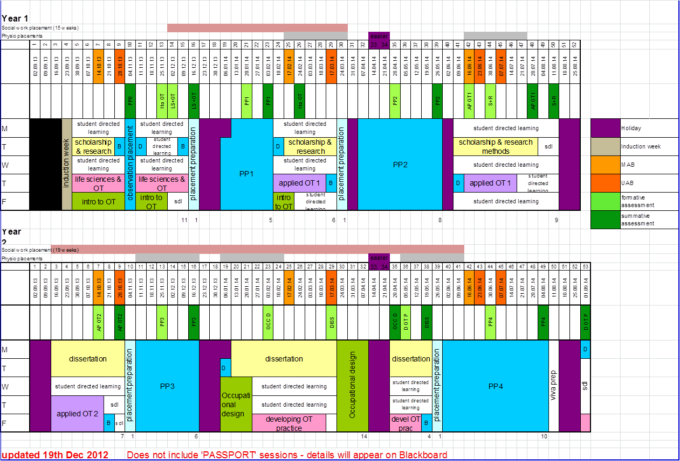
Summary of content of academic modules (placements not included)
Level 7 | Module Aims | Module Content
HRBO 7020 Introduction to Occupational Therapy | The aim of this module is for students to develop detailed knowledge and understanding of occupational therapy core skills and professional practice. They will synthesise various theoretical perspectives, in order to begin to contextualise their interventions. They will also develop understanding of the skills required for safe and effective practice. | Development of the profession, OT core skills, OT process, activity/occupational analysis, therapeutic use of self, occupation, assessment, intervention, outcome measures, models of practice, approaches, frames of reference, clinical reasoning and problem solving, reflection, practical aspects, examples of OT practice, role, creativity, OT as a complex intervention, introduction to CPD, employability.
HRBO 7021 Life Sciences and Occupational Therapy | The aim of this module is to develop knowledge of the science of occupation and explore its relevance to understanding humans as occupational beings. Students will study, analyse and apply normal human development across the lifespan from an occupational perspective. The intention is for students to synthesise and utilise knowledge of physical, social and psychological perspectives into an understanding of the person as an occupational whole. | Anatomy, physiology, psychology, sociology, occupational science, mental health/ physical health balance, consideration of own health, occupational and activity analysis.
HRBO 7022 Scholarship and Research Methods | The aim of this module is to enable students to develop the academic & scholarly skills required to work at master’s level. This module will also give students an advanced understanding of research design, selected research methods and opportunities for acquiring appropriate research skills through practical experience. | Masters level study skills – critical writing, critiquing articles, critical discussion; independent learning skills, EBP, research methods. Digital Skills; information literacy. Ethics and governance skills. Collaborative project working.
HRBO 7023 Applied Occupational Therapy (1) | The aim of this module is to integrate theoretical knowledge of life sciences and human occupation into practice contexts of occupational therapy. The focus will be on applying the occupational therapy process to deliver best practice. | Conditions, application of models of practice, application of life sciences, environmental contexts of occupation, group work, EBP, clinical reasoning, reflection, policy & legislation, quality assurance, communication, team working, professional skills, professional identity, role, understanding requirements of professional and regulatory bodies, experts by experience.
HRBO 7024 Applied Occupational Therapy (2) | The aim of this module is to integrate theoretical knowledge of life sciences and human occupation into specialist and emerging practice contexts of occupational therapy. The focus will be on applying the occupational therapy process to deliver best practice. | OT in emerging practice, health promotion and prevention, application of models of practice, application of life sciences, specialist and emerging environmental contexts of occupation, group work, recognising and utilsing appropriate evidence, clinical reasoning, reflection, influencing policy & legislation, quality assurance, communication, interagency working, professional identity, role.
HRBO 7025Occupational Design | To provide an opportunity to critically debate a wide range of occupational therapy practice settings:  • Students will work in small groups to design, implement and evaluate an occupational therapy intervention.  • Students will critically explore the role of occupational therapy in statutory and non-statutory settings.  • Students will work together to further enhance knowledge of theory underpinning practice and professional skills. | Specialist speakers from statutory and non-statutory settings, policy drivers, legislation, occupational therapy philosophy, occupational science, entrepreneurial skills, team working skills, reflection, reflexivity, project design, project implementation, project evaluation, person centred practice, occupational/activity analysis.
HRBO 7026 Developing Occupational Therapy Practice | To develop knowledge and skills to ensure sustainability of the occupational therapy profession. To promote entrepreneurial and leadership skills in order to respond to cultural, societal and health related issues. To encourage students to apply themselves effectively to contemporary workplaces by developing the professional skills required to enable them to articulate their knowledge and skills using appropriate media. | Theories of organisational behaviour, leadership, emerging and potential areas of occupational therapy practice, entrepreneurship and business skills, current concepts relating to occupational science and occupational therapy, political influences on practice, action planning, CPD portfolio, preceptorship, supervision, employability skills, representing self as a professional.
HRBO 7027 Dissertation | The dissertation allows students to demonstrate their ability to work at master’s level to independently produce a research-based study on a negotiated topic related to occupational therapy. | Students will develop their research proposal into a project. This could include participation in inclusive staff/student research projects. Students will also evaluate their research skills through completing a developmental research portfolio/log.

APPENDIX 2
Practice Placement Record
Total Hours completed by Student whilst on Placement
Name: ……………………………………………………………………………………… Placement: PP0, PP1, PP2, PP3, PP4 (please circle)
Name of Practice Educator: ………………………………………………………………

Placement Address: ……………………………………………………………………………………………………………………………

 | Monday | Tuesday | Wednesday | Thursday | Friday | Weekly Total
Week 1
Week 2
Week 3
Week 4
Week 5
Week 6
Week 7
Week 8
Total Hours

Total Number of days absent
Practice Educator’s Signature ………………………………………………………………. Date …………………….
APPENDIX 3

Quality Group for Rehabilitation & Social Work

LEARNING CONTRACT - PRACTICE PLACEMENT EDUCATION

Name of Student: |  | Supervision  Time:
Name of Practice  Educator: |  | Final Report  (Date & Time)
Area of Work: |  | Placement:

GUIDELINES FOR COMPLETION

After an induction period (normally end of the first week), all students should be able to contribute to discussion about what they want to achieve from their placement - their learning outcomes. These learning outcomes should reflect the university Aims and Outcomes for the level of placement. The learning contract is a negotiated practical agreement between the practice educator and the student. The negotiation allows the students to take responsibility for their learning, and clarifies both the student and educator’s roles. *Remember*, keep the learning outcomes simple, realistic and don’t be too ambitious. The contract will normally be made during the first week of the placement to be reviewed regularly.

The Learning Contract is not assessed; it is a tool to enable the student to maximise her/his learning. Contracts should be returned to university with Assessment Forms.

QUALITY GROUP FOR REHABILITATION

LEARNING CONTRACT - PRACTICE PLACEMENT EDUCATION

LEARNING OUTCOMES  What do I want to learn or develop during this  placement? | LEARNING METHODS  What learning strategies  will I employ? | LEARNING RESOURCES  What resources do I need  Access to in order to  Achieve my learning  Outcomes: | EVIDENCE  How can I show myself and my practice educator that I have met my learning outcomes? What proof will I offer and when? | DATE  ACHIEVED/  PRACTICE EDUCATOR AND STUDENT INITIAL

APPENDIX 5


QUALITY GROUP FOR REHABILITATION and SOCIAL WORK

STUDENT PRACTICE PLACEMENT EVALUATION

HALF-WAY/FINAL REPORT*
*delete as appropriate

PP
GENERAL INFORMATION

Student's Name: Placement Dates:

Practice Educator’s Name:

Location: Number of Placement Hours:

Type of Placement:

Outcome: PASS/FAIL
(only on final report)
__________________________________________________________________________

RECOMMENDATIONS
(with guidelines)

__________________________________________________________________________

PRACTICE EDUCATOR’S GENERAL SUMMARY Date:

Signature:
__________________________________________________________________________

STUDENT'S GENERAL SUMMARY Date:

Signature:
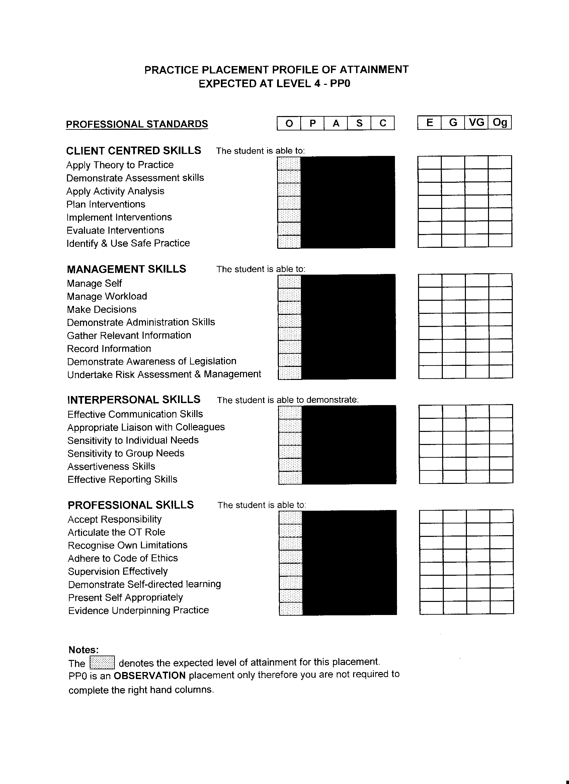
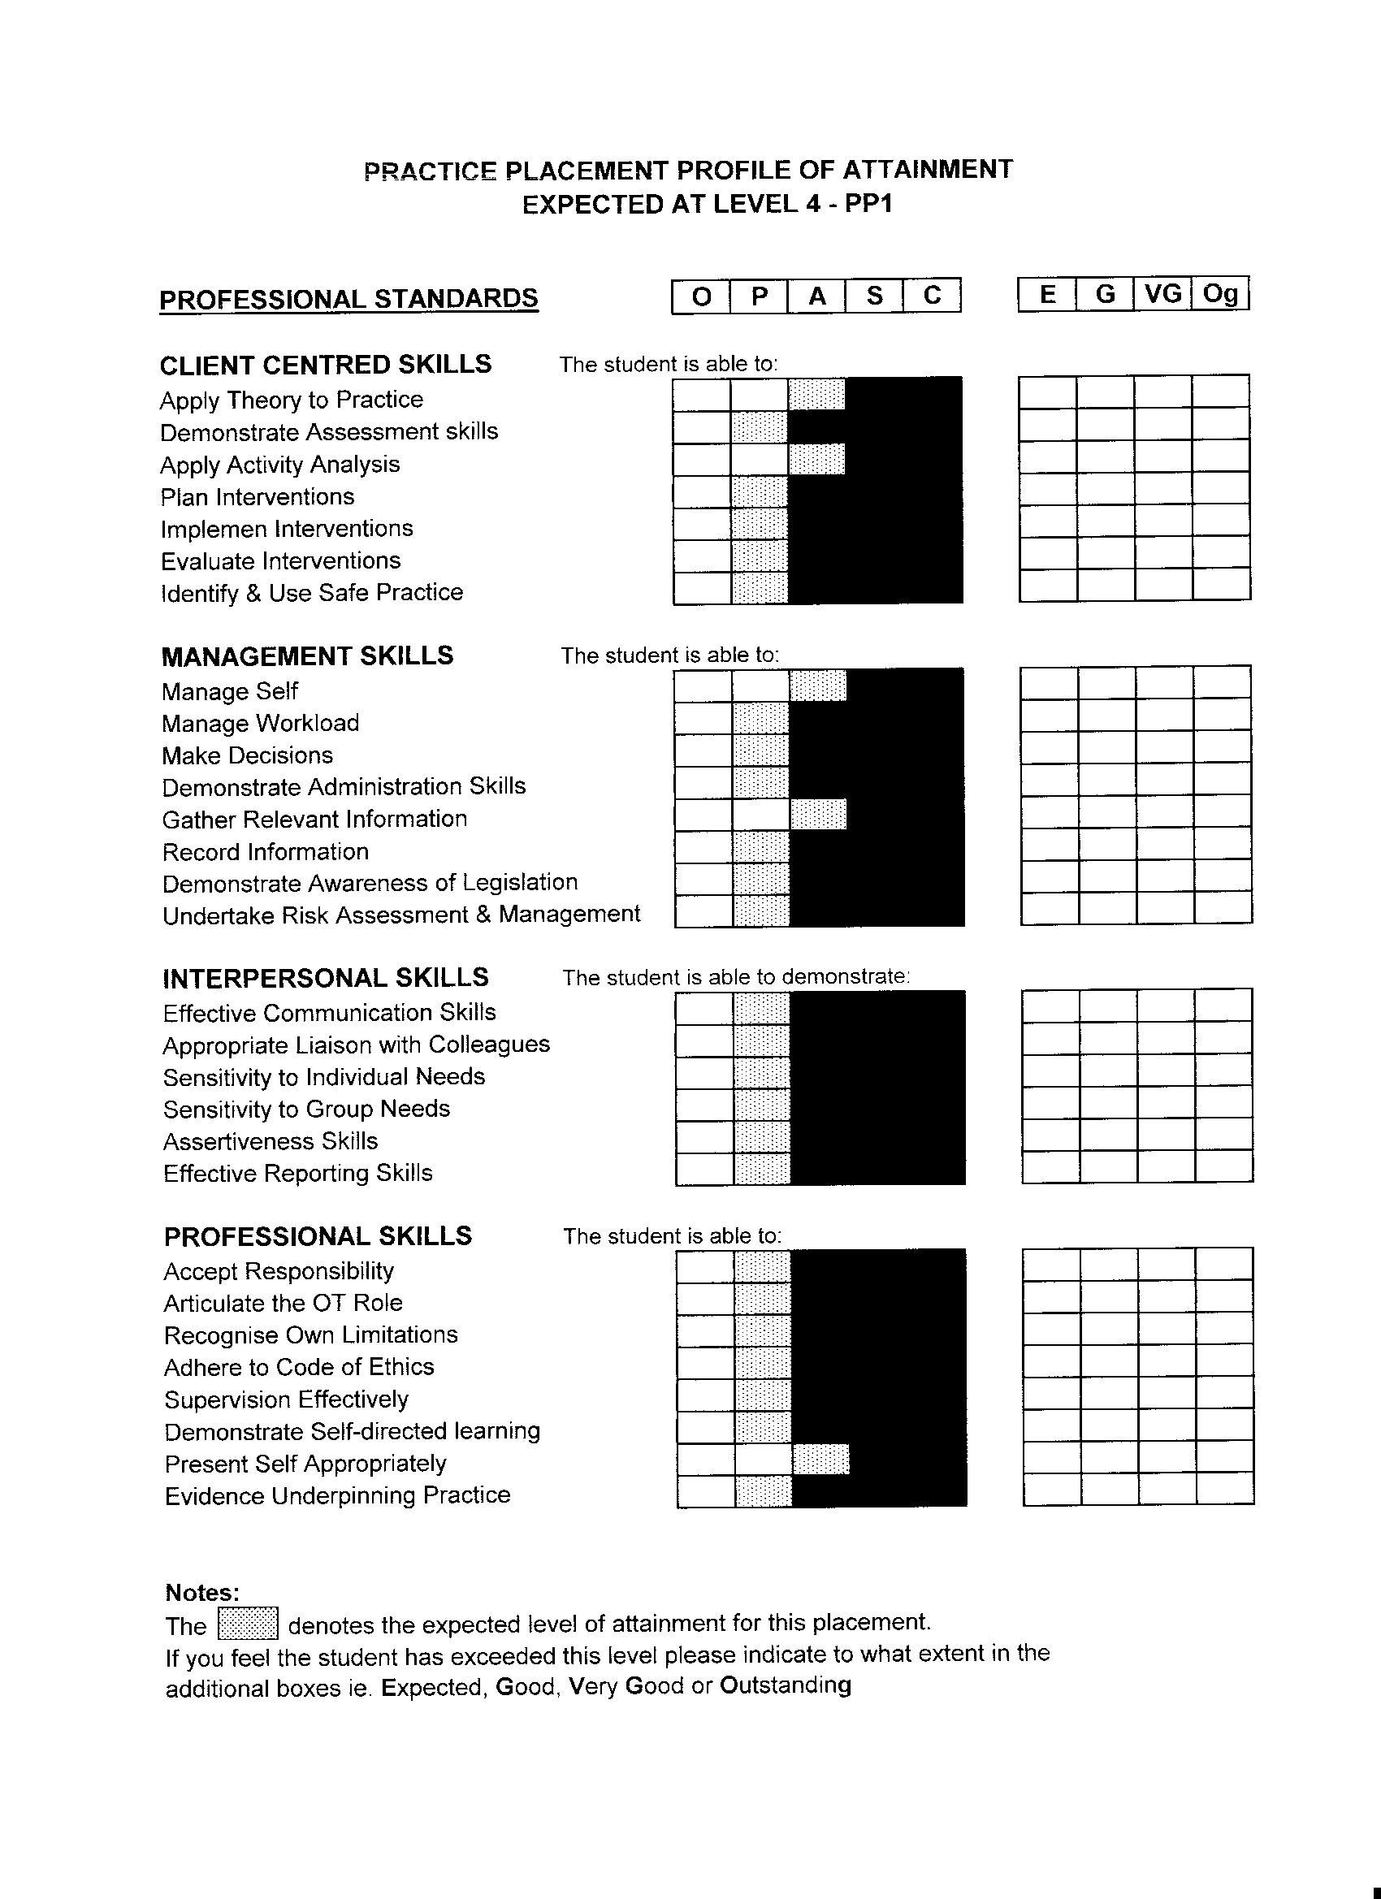
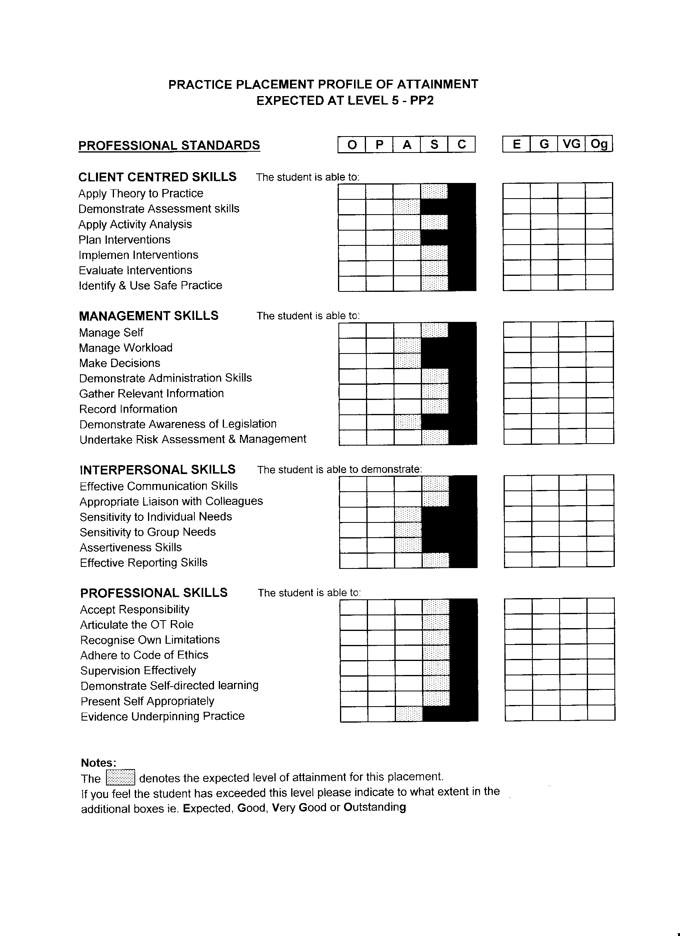

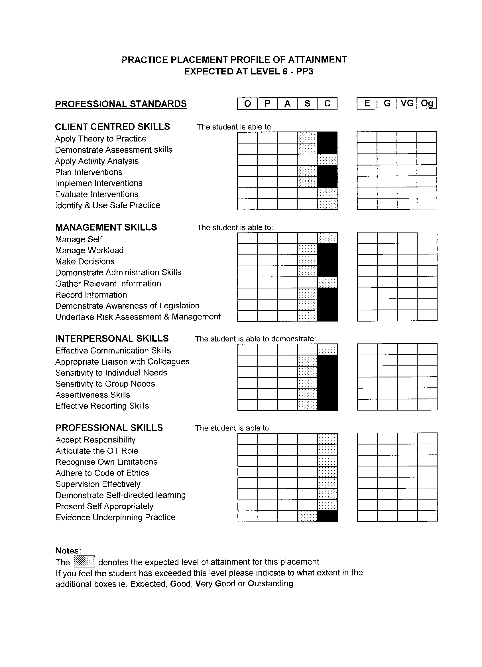
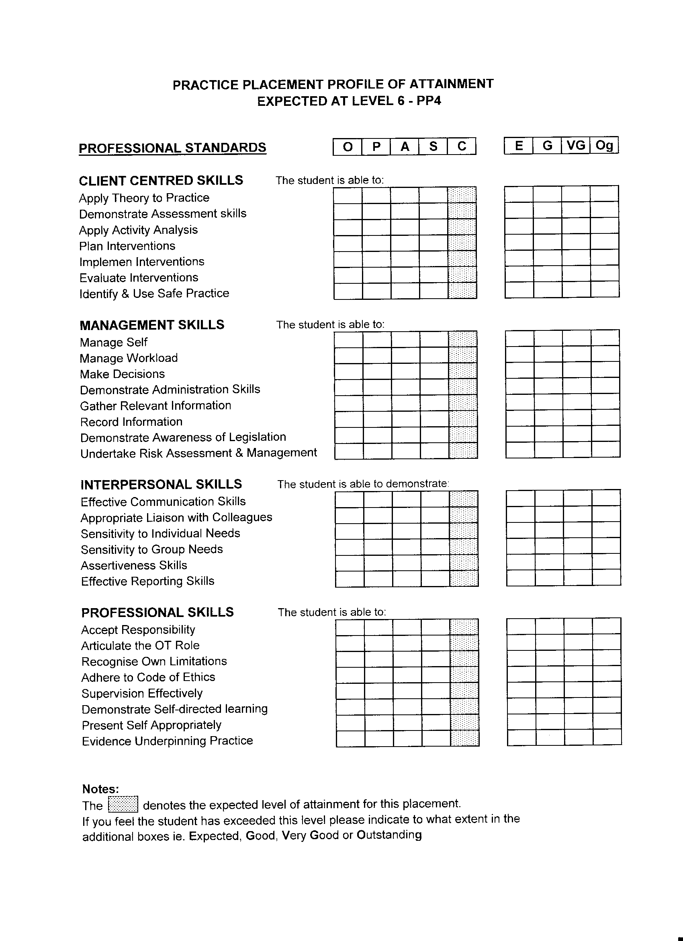
PRACTICE EDUCATOR’S COMMENTS Date:
_____________________________________________________________________

CLIENT CENTRED SKILLS

_____________________________________________________________________

MANAGEMENT SKILLS

_____________________________________________________________________

INTERPERSONAL SKILLS

PROFESSIONAL SKILLS

COMMENTS FROM EXPERTS BY EXPEREINCE (Users & Carers)

APPENDIX 6 Practice Placement Level Descriptors

Level 4 - PP1

Outstanding | From the outset the student consistently achieves an exceptionally high standard of practice for the skill area. They demonstrate exceptional comprehension with a thorough knowledge & understanding of theories, concepts and models which go beyond that covered in the programme. The student is able to apply these principles to the practice context at all times. They demonstrate a sophisticated ability to analyse and reflect on practice and are able to reach their own appropriate conclusions to problems. Students demonstrate that they are resourceful, imaginative and use their initiative at all times.
Very Good | The student consistently demonstrates that they are able to carry out the skill to a very high standard. They demonstrate sound knowledge & understanding and are able to apply this in the practice context. Their work shows evidence of ability to analyse and reflect on practice using models, concepts and theories covered in the programme and are able to reach some conclusions to problems. Students demonstrate that they are resourceful, imaginative and able to use their initiative at times.
Good | The student demonstrates that they are able to carry out the skill to a higher level than the baseline expected for this placement. They demonstrate relevant knowledge and understanding and are able to apply this themselves in the practice context. There is evidence that the student has applied given tools and / or methods accurately to practice and problems without assistance from the educator.
Expected | The student demonstrates that they have met the expected profile for this skill.  The student demonstrates that they can participate in or assist the educator with the skill. They demonstrate basic knowledge and understanding of the key theories, concepts and models studied to date and are able to apply these in the practice context with help from the educator. The student will require help from the educator to analyse and reflect on their practice and will require direction in all aspects of the departments work.  Work shows evidence that the student has applied given tools/methods to well defined practical contexts and/or problems.
FAIL | The student has not developed skills to meet the assessment profile for this placement. This student is still at the observation or participation level for a given skill. The student has no, incorrect or little knowledge of the theories, concepts, tools and methods studied in the programme so far and are unable to apply these to the practice context. They are unwilling or unable to participate in the work of the department. The student does not use supervision as a learning / developmental experience and does not act on advice or progress during the placement experience.

Level 5 – PP2

Outstanding | From the outset the student consistently achieves an exceptionally high standard of practice for the skill area. They demonstrate exceptional comprehension with a detailed and impressive knowledge & understanding of theories, concepts and models which go beyond that covered in the programme. The student is able to apply these principles to the practice context at all times. They demonstrate a sophisticated ability to analyse and reflect on practice and are able to reach their own appropriate conclusions to problems. Students demonstrate that they are resourceful, imaginative and use their initiative at all times.
Very Good | The student consistently demonstrates that they are able to carry out the skill to a very high standard. They demonstrate detailed knowledge & understanding of the theories, concepts and models studied and are able to apply these in the practice context. Their work shows evidence of the ability to analyse and reflect on practice and to be able to reach appropriate conclusions to straightforward problems in a considered manner. Students demonstrate that they are resourceful, imaginative and able to use their initiative most of the time.
Good | The student demonstrates that they are able to carry out the skill to a higher level than the baseline expected for this placement. They demonstrate sound knowledge and understanding of the theories, concepts and models studied and are able to apply these in the practice context. There is evidence that the student has applied given tools and / or methods accurately to practice and problems without assistance from the educator. The student is able to use their own judgement, imagination and initiative some of the time to undertake the skill.
Expected | The student demonstrates that they have met the expected profile for this skill.  The student demonstrates that they can assist the educator or work under supervision for that skill. They demonstrate basic knowledge and understanding of the key theories, concepts and models studied and are able to apply these in the practice context. The student will require help from the educator to analyse and reflect on their practice and will require direction in all aspects of the departments work.  Work shows evidence that the student can apply essential learning to straightforward problems and or practical contexts.
FAIL | The student has not developed skills to meet the assessment profile for this placement.  This student is still at the observation, participation or assistance level for a given skill. The student has no, incorrect or little knowledge of the theories, concepts, tools and methods studied in the programme so far and are unable to apply these to the practice context. They are unwilling or unable to participate in the work of the department. The student does not use supervision as a learning / developmental experience and does not act on advice or progress during the placement experience.

Level 6 – PP3

Outstanding | From the outset the student consistently achieves an exceptionally high standard of practice for the skill area. They demonstrate exceptional scholarship with a comprehensive and up to date knowledge & understanding of theories, concepts and models which go beyond that covered in the programme. The student is able to apply these principles to the practice context at all times independently. They demonstrate a sophisticated ability to synthesise, analyse and reflect on practice and are able to reach their own appropriate conclusions to problems. Students demonstrate that they are resourceful, imaginative and use their initiative at all times.
Very Good | The student consistently demonstrates that they are able to carry out the skill to a very high standard. They demonstrate comprehensive and up to date knowledge & understanding of the theories, concepts and models studied to date and are able to apply this in the practice context. Their work demonstrates the ability to analyse, evaluate and reflect on practice and they are able to reach appropriate conclusions to problems independently. Students demonstrate that they are resourceful, imaginative and able to use their initiative.
Good | The student demonstrates that they are able to carry out the skill to a higher level than the baseline expected for this placement. They demonstrate detailed knowledge and understanding of the theories, concepts and models studied to date and are able to apply this in the practice context. There is evidence that the student has applied given tools and / or methods accurately to practice and problems without assistance from the educator. The student is able to use their own judgement, imagination and initiative some of the time to undertake the skill.
Expected | The student demonstrates that they have met the expected profile for this skill.  The student demonstrates that they can work under supervision and at the level of a newly qualified OT for that skill. They demonstrate basic knowledge and understanding of the key theories, concepts and models studied to date and are able to apply these in the practice context. The student is able to analyse, evaluate and reflect on their practice independently. The student can apply appropriate learning accurately to problems within the practice context.
FAIL | The student has not developed skills to meet the assessment profile for this placement. This student is still at the observation, participation, assistance or supervision level for a given skill. The student has no, incorrect or little knowledge of the theories, concepts, tools and methods studied in the programme so far and are unable to apply these to the practice context. They are unwilling or unable to participate in the work of the department. The student does not use supervision as a learning / developmental experience and does not act on advice or progress during the placement experience.

Level 6 – PP4

Outstanding | From the outset the student consistently achieves an exceptionally high standard of practice for the skill area. They demonstrate exceptional scholarship with a comprehensive and up to date knowledge & understanding of theories, concepts and models which go beyond that covered in the programme. The student is able to apply these principles to the practice context at all times independently. They demonstrate a sophisticated ability to synthesise, analyse and reflect on practice and are able to reach their own appropriate conclusions to problems. Students demonstrate that they are resourceful, imaginative and use their initiative at all times.
Very Good | The student consistently demonstrates that they are able to carry out the skill to a very high standard. They demonstrate comprehensive and up to date knowledge & understanding of the theories, concepts and models studied to date and are able to apply this in the practice context. Their work demonstrates the ability to analyse, evaluate and reflect on practice and they are able to reach appropriate conclusions to problems independently. Students demonstrate that they are resourceful, imaginative and able to use their initiative.
Good | The student demonstrates that they are able to carry out the skill to a higher level than the baseline expected for this placement. They demonstrate detailed knowledge and understanding of the theories, concepts and models studied to date and are able to apply these in the practice context independently. There is evidence that the student has applied given tools and / or methods accurately to practice and problems without assistance from the educator and uses judgement and reasoned argument to justify decisions. The student is able to use their own judgement, imagination and initiative some of the time to undertake the skill.
Expected | The student demonstrates that they have met the expected profile for this skill.  The student demonstrates that they can work independently at the level of a newly qualified OT for that skill. They demonstrate basic knowledge and understanding of the key theories, concepts and models studied to date and are able to apply these appropriately in the practice context independently. The student is able to analyse, evaluate and reflect on their practice. The student can apply appropriate learning accurately to problems within the practice context.
FAIL | The student has not demonstrated the skill level to meet the assessment profile for this placement. This student is still at the observation, participation, assistance or supervision level for a given skill. The student has no, incorrect or little knowledge of the theories, concepts, tools and methods studied in the programme and are unable to apply these to the practice context. They are unwilling or unable to participate in the work of the department. The student does not use supervision as a learning / developmental experience and does not act on advice or progress during the placement experience.

APPENDIX 7
Information Services

Registration form for student mentors, educators or assessors.

SURNAME……………………………………………………… TITLE…………………..

FORENAMES…………………………………………………………………………………

HOME ADDRESS…………………………………………………………………………….

………………………………………………………………………………………………….

………………………………………………………………………………………………….

POSTCODE………………………………………………TELEPHONE……………………

EMAIL …………………………………………………….

Nursing and midwifery mentors only Education mentors only
NMC pin number……………………. DfES number……………………………

WORK ADDRESS……………………………………………………………………………..

…………………………………………………………………………………………………
POST CODE……………………………….. TELEPHONE………………………………….

DECLARATION
I wish to become a member of the library. I agree to abide by the LIS rules and regulations and to be responsible for the safe return of all materials borrowed in my name. I agree that my personal details can be stored on the LIS database, for LIS purposes only.

SIGNATURE……………………………………………. DATE………………………………

CONFIRMATION OF ELIGIBLITY.
I can confirm that the above named is on the mentor register.

NAME……………………………………….. SIGNATURE…………………………………..

POSITON AT UoC………………………………….. FACULTY……………………………..

FOR IS STAFF USE:

READER CARD NUMBER……………………….. EXPIRY DATE……….........................

