Using MS Word ‘Styles’ to Format Your Thesis

Contents
Contents 1
Why use Styles? 2
The ‘Normal' style 2
How to change the ‘Normal' style 2
Using Heading Styles 5
Heading 1 5
Heading 2 5
Heading 3 5
Applying a heading style 5
Modifying a heading style 6
Suggestions for formatting your heading styles (not mandatory) 7
Viewing heading styles via the Navigation Pane 7
Reorganising content via the Navigation Pane 8
Table of contents 8
To insert a Table of Contents 9
To update the Table of Contents 9
How to save from Word to a PDF with bookmarks 10

Why use Styles?
If you are writing a long document such as a thesis, we recommend that you use Styles to format the text – but this is not a mandatory requirement for University of Cumbria PgR Assessment Regulations.
A style is a predefined set of text formatting attributes that affect how text looks. You can modify a style to suit your requirements at any time, and all characters or paragraphs formatted with that particular style are automatically updated to reflect the changes.
They are beneficial to your document because…
- They keep formatting consistent throughout the document
- You can create and apply your own styles
- They offer timesaving features, such an automatic navigation pane and table of contents, making it easier for your readers and examiners to read your work.

The ‘Normal' style
Every time you begin typing in a new Word document, you are already using a style called ‘Normal’. It formats the text you see – the font, size, colour, etc. – according to how the style has been defined. You can ‘modify’ this normal style to suit the needs of your thesis.
For example, the University of Cumbria PgR Assessment Regulations specifies 1.5 or double line spacing and you can ‘modify’ this in the Normal style and the changes will apply to all of the text in your document.
The quickest way of finding Styles, and the ‘Normal’ style, is in the Styles Gallery on the Home tab.
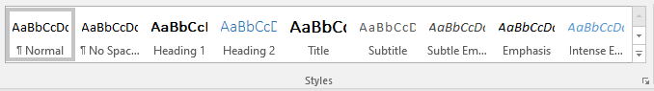

How to change the ‘Normal' style
- On the Home tab, in the Styles gallery, right-click on the ‘Normal’ button.
- Choose the Modify option (with the pencil icon next to it), and the Modify Style dialog box is displayed.
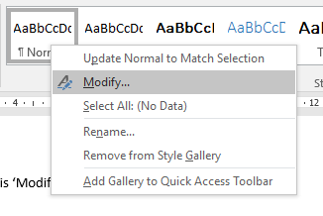
You should now see this ‘Modify Style’ box
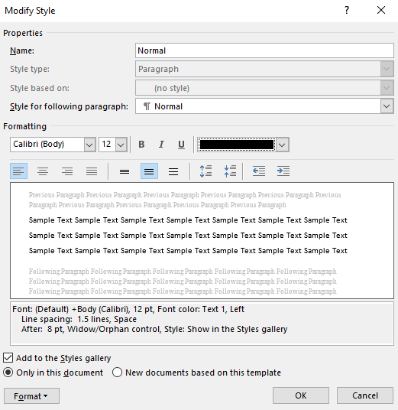
For the sake of illustration, let us say that we want the body of the text in our thesis to have the following style: Font: Calibri (Body); Font Size: 12 points; Colour: Black; Line spacing: 1.5.
- In the Formatting section of the Modify Style box:
- Select Calibri (Body) from the Font list.
- Ensure the Font size is 12 points, and the colour is black
- To change line spacing, click on the Format button at the bottom left of the box, and select the Paragraph option.
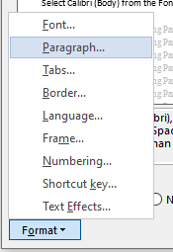
- In the Line Spacing area, choose 1.5. Click OK.
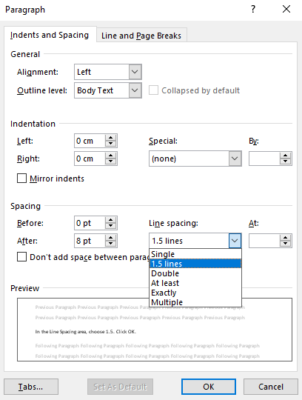
- Click the OK buttons to save your changes and exit the dialog boxes.

Using Heading Styles
The purpose of the chapters, sections and subsections within your thesis are to provide a clear structure for your content, and they need to be indicated by the use of headings.
Word actually provides up to nine levels of heading styles to help you to create a hierarchical structure. It is your decision how many heading levels your document requires, but most theses do not exceed four heading levels.
The first two heading styles are visible in the Styles Gallery on the Home tab.
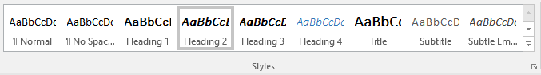

Heading 1
Apply this style for the highest level of headings in your document. It is the equivalent of ‘Chapter one’, Chapter two, etc.

Heading 2
Apply this style for your document’s sub-headings

Heading 3
Apply this style if your document’s sub-headings have further sub-headings. Please note that the Heading 3 and Heading 4 options will only appear on the Styles Gallery once you have already applied Heading 2.

Applying a heading style
- Select, or type, the first heading in your document, e.g. Chapter 1.
- Click on the relevant Heading Style button for your document title. You need to decide which level of heading style is required…
  - if it is a top level heading, apply the Heading 1 style
  - if it is a sub-heading, then apply Heading 2 style

Modifying a heading style
- Right-click a Heading Style button in the Styles Gallery: e.g. Heading 1.
- Choose Modify to display the Modify Style dialog box.
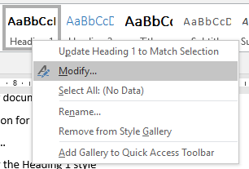
- Make the formatting changes in the Formatting area
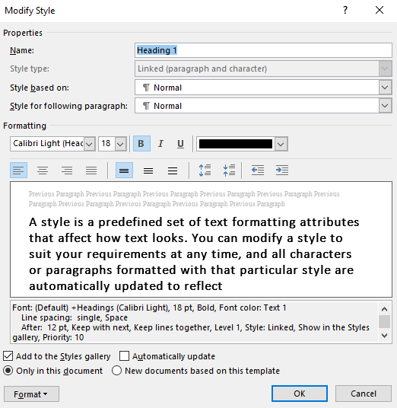
- Click on the Format button at the bottom left, and select the Paragraph option from the list.
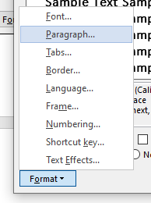
- Apply paragraph ‘Spacing’ to your headings using the arrow buttons to increase or decrease, or type directly into the ‘Before’ and/or ‘After’ boxes.
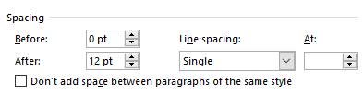

Suggestions for formatting your heading styles (not mandatory)
 | Heading 1 | Heading 2 | Heading 3 | Heading 4
Font | 18pts, Bold | 16pts, Bold | 14pts, Bold | 12pts, Bold
Spacing | Before – 0pts | Before – 18pts | Before – 18pts | Before – 12pts
 | After – 12pts | After – 12pts | After – 6pts | After – 0pts

Viewing heading styles via the Navigation Pane
Once you begin applying heading styles to your document headings you will be able to access this excellent navigational tool. It displays your heading titles as links – click on one and you move immediately to that part of the document. This will help your readers and examiners to navigate your thesis.
It also provides an at-a-glance view of the structure of your document, helping you to organise your content as you work.
- Click the View tab on the Ribbon, and select Navigation Pane in the Show group.
- Your document headings will be displayed on the left of the screen.
- Click on a heading link to navigate to that part of the document.
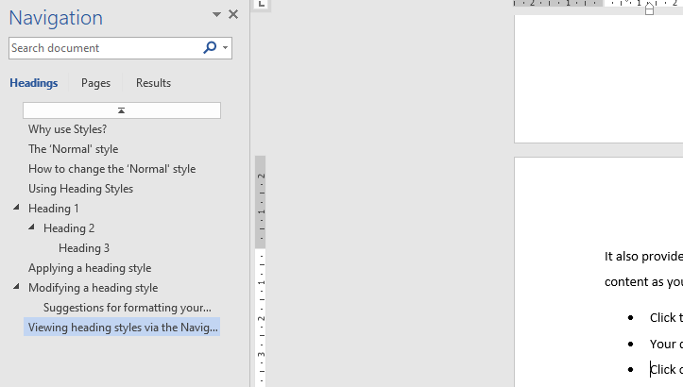

Reorganising content via the Navigation Pane
You can reorganise your content with ease by using click and drag to move content around via the Navigation pane.
To use this feature
- Click and drag a heading on the Navigation pane to a new position in the list.
- As you drag the mouse a thick moveable line will appear.
- At the new position in the Navigation pane, release the mouse button. The heading – and all content within its area, text, charts, tables, and so on —have moved to a new location within the document.

Table of contents
When you apply heading styles in your document you can create an automatic table of contents. It lists your headings with their page numbers and acts as a navigational tool too.
Before proceeding, make sure that you insert page numbers to your whole thesis – make sure that you follow the guidance on pagination in the University of Cumbria PgR Assessment Regulations.
To add page numbers:
- Click on the Insert tab on the Ribbon.
- In the Header & Footer group, click Page Number.
- Choose where you want the page number to appear – in this document, bottom centre has been chosen.

To insert a Table of Contents
- On the References tab, in the Table of Contents group, click Table of Contents.
- Select Automatic Table 1 or Automatic Table 2.
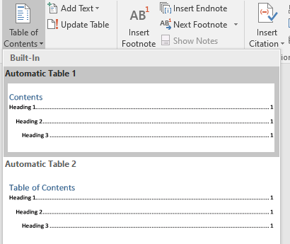

To update the Table of Contents
You must remember to update the Table of Contents when you have added, deleted or changed a heading in the main body of your document.
- Click on the Table of Contents to select it. It will be highlighted in grey.
- Click on its ‘Update Table’ button, at the top of table.
- Select ‘Update entire table’ (updates both headings and page numbers)
- Click OK.

How to save from Word to a PDF with bookmarks
- In Word, click the "File" tab and click "Save As".
- Select "PDF" from the Save as drop-down list.
- Under "Options," be sure that the option "Create bookmarks using: Headings" is checked.
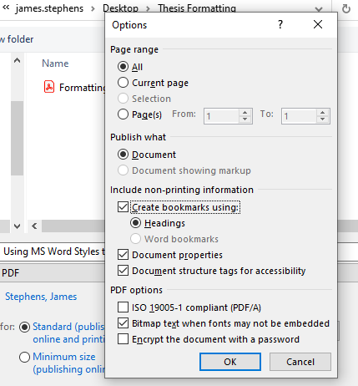
When your reader or examiner opens the PDF version of your submitted thesis they can now click on the Bookmarks icon and use the bookmarks pane to navigate your work.
