UNIVERSITY OF CUMBRIA
COURSEWORK REASSESSMENT REQUIREMENT
Module Code: HSOB4005

Module Title: Molecular Biology

Tutor: Dr. Wendy Davidson

Title of the item of work: Assignment 3: Mechanisms of inheritance

Learning Outcomes

LO 4: Demonstrate knowledge of the principles of inheritance.

Details and Criteria
This assignment is weighted at 20% of the module.

A series of questions can be found below which collectively address the basic principles of inheritance. Work through each question, ensure that where required full working is presented (e.g. punnet squares, pedigree chart construction, calculations).

Question sheet:
Mendel’s Laws of Inheritance: Please present all Punnet squares
- In peas, seeds may be round (R) or wrinkled (r). What proportion of the offspring in the following crosses would be expected to be wrinkled?
a. RR x rr b. Rr x Rr c. Rr x rr
(6 marks)
- In peas the stem length may result in a tall (T) or dwarf (t) plant. What proportion of the offspring in the following crosses would be expected to be tall and what proportion dwarf?
a. TT x tt b. TT x Tt c. Tt x Tt d. tt x Tt
(8 marks)
- What proportion of plants from the following crosses would be tall with yellow (Y), wrinkled seeds?
a. TtYYRr x ttYYrr b. TTYyRr x TtYyRr
c ttYyrr x ttyyRr d. TtYyRr x TtYyRr
(12 marks)
- Pure breeding snapdragons exhibit many colour variants: e.g. red or white. When you breed a red with a white all progeny are pink. It was initially felt that the stronger of the two colours would always dominate and thus all F1 would ultimately be red therefore how do you explain the presence of pink?
(2 marks)
- If you were to take the F1 snapdragon progeny (pink) and cross them with a fellow pink the results differ in that: 25% are red, 50% pink and 25% white (1:2:1 ratio). CREATE A PUNNET SQUARE TO DEMONSTRATE BOTH THE ORIGINAL PARENTAL CROSS AND THE RESULTING F1 CROSS. Present the phenotypic and genotypic ratios for both crosses.
(8 marks)

6. A dominant gene, A, causes yellow colour in rats. The dominant allele of another independent gene, R, produces black coat colour. When the two dominant genes occur together (A-R-), they interact to produce grey coat colour. Rats of the double recessive genotype are cream-coloured. If a grey male and a yellow female are mated and produce approximately 3/8 yellow, 3/8 grey, 1/8 cream, and 1/8 black, what were the genotypes of the parents?
(6 marks)

7. The following punnet square based on the coat colour of Labrador dogs identifies a 9:3:4 ratio whereby 9 of the progeny are black, 3 chocolate and 4 yellow (not the typical 9:3:3:1). Are you able to identify the genetic phenomenon at work here? Discuss what is happening and how this altered ratio has occurred.
(5 marks)
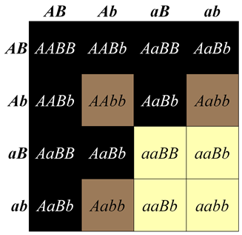

8. In cocker spaniels the following genotypes and phenotypes are found: AABB = white A-bb = red aabb = lemon AaB- = black aaB- = liver AABb = grey.
If two cocker spaniels of the genotypes below are mated and eight pups are born what is the most likely distribution of coat colours in that litter?
P1 AaBb x AABb
______white ______red ______lemon ______black ______liver ______ grey
(3 marks)

9. What is genetic cross between an individual showing a dominant phenotype (but unknown genotype) and a homozygous recessive individual called and what is the purpose of conducting such a cross?
(2 marks)

10. In humans’ dark hair (B) is dominant over blonde (b), and colour blindness (c) is a sex-linked recessive trait. A woman has a blonde brother, a blonde mother, and a dark-haired father. Her brother and her parents have normal vision. She bears the following three children by her blonde, normal-vision husband:
- dark-haired son with normal vision
- dark-haired daughter with normal vision
- dark-haired colour-blind son
a. Create a pedigree of the entire family showing the probable genotypes of all individuals.
b. What is the probability her next child will be a colour-blind boy?
c. If her fourth child is a boy, what is the probability that he will have dark hair?
(10 marks)

11. Answer the questions about the pedigree chart below.
a. What is the pattern of inheritance depicted? Is it: autosomal dominant, autosomal recessive, sex-linked dominant, sex-linked recessive, Y-linked.
b. WHY are the other patterns ruled out?
c. Write the genotypes for all individuals - use "A" to represent a dominant allele & "a" to represent a recessive allele, if one allele is unknown, use "?" to represent that allele.
Generation #1 -
Generation #2 -
Generation #3 -
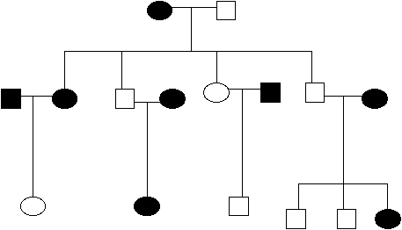

(10 marks)
12. You have been provided with a case history relating to a specific family. Using the information provided construct a clinical pedigree chart. Present as much knowledge as possible e.g. age, living, deceased, consanguinity, affected status, legends etc.
(20 marks)

13. A cat breeder crossed 2 white cats expecting all the progeny to be white, however, there were 2 tabby and one black kitten amongst them. The mating was repeated and again the variation in colours was present. It was suggested that the two white cats each possess a dominant colour-suppressing gene and that through the mating non-suppressing alleles segregate to some of the kittens (generating colour). To test this a third mating was conducted and the collective figures were:
17 white, 5 tabby and two black kittens. Use a chi square test to determine whether the suggested hypothesis was correct.
(8 marks)
Total /100 marks

SUBMISSION DATE AS PER STUDENT PORTAL

To be submitted by 4 PM on 05/05/23 via Turnitin on the Module
Blackboard site.

