UNIVERSITY OF CUMBRIA
COURSEWORK REASSESSMENT REQUIREMENT
Module Code: HSOS6106

Module Title: Dissertation

Tutor: Nigel Smith/Supervisor as previously allocated

Title of the item of work: Thesis

Wordage: 10000 words

Summary
You must produce a written dissertation thesis which demonstrates your ability to undertake an independent piece of in-depth research into a topic of your choice.

Details
You are required to resubmit your written thesis for your dissertation. Please make sure you comply with the following guidelines.

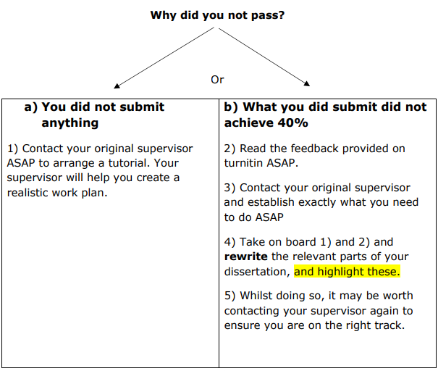
Notes
Common reasons for failure at assessment include one or more of the following:
- Not addressing the question at all or in full. Is it possible you didn’t understand the intent of the question? Read it again and ensure you use academic sources and define key terms. Create a tick list and ensure each area is addressed, ask someone else to read your work to see if they can spot each area.
- Errors applying/describing relevant theory. Check your sources? Make sure you read original sources (often made available on Bb) and read a number of sources regarding that theory. Ensure you define key terms and use the terms accordingly.
- Not drawing on core theory or insufficient core theory used. Seek to focus on key areas but find and read all you can in these areas.
- Weak presentation, layout, referencing, structure leading to a confused message. Reference all photos, charts and assertions both in-text and in your reference list. Use subheadings and ensure the text within each addresses these.
- A scant answer in areas which just falls short at each stage. Make sure each section is focussed not padded!.

Please note
- Your supervisor is keen to support you in passing your resubmission, but it is your responsibility to drive this. They are waiting to hear from you!
- Please do not underestimate the work needed for this resit, this isn’t one to leave until the last minute.
IF IN DOUBT – SEEK GUIDANCE please.
Either – your supervisor or Nigel, as module leader.

Grading Criteria
Grading criteria are published on the module Blackboard site.

SUBMISSION DATE AS PER STUDENT PORTAL

Submit via Turnitin to the relevant submission point on the module Blackboard site by 4pm on the date stipulated by the University Progression and Award Board.

